Exercise base-loop

**1.- Create functions that show the elements of a vector (one that uses for loop; another while; and last one with repeat).**

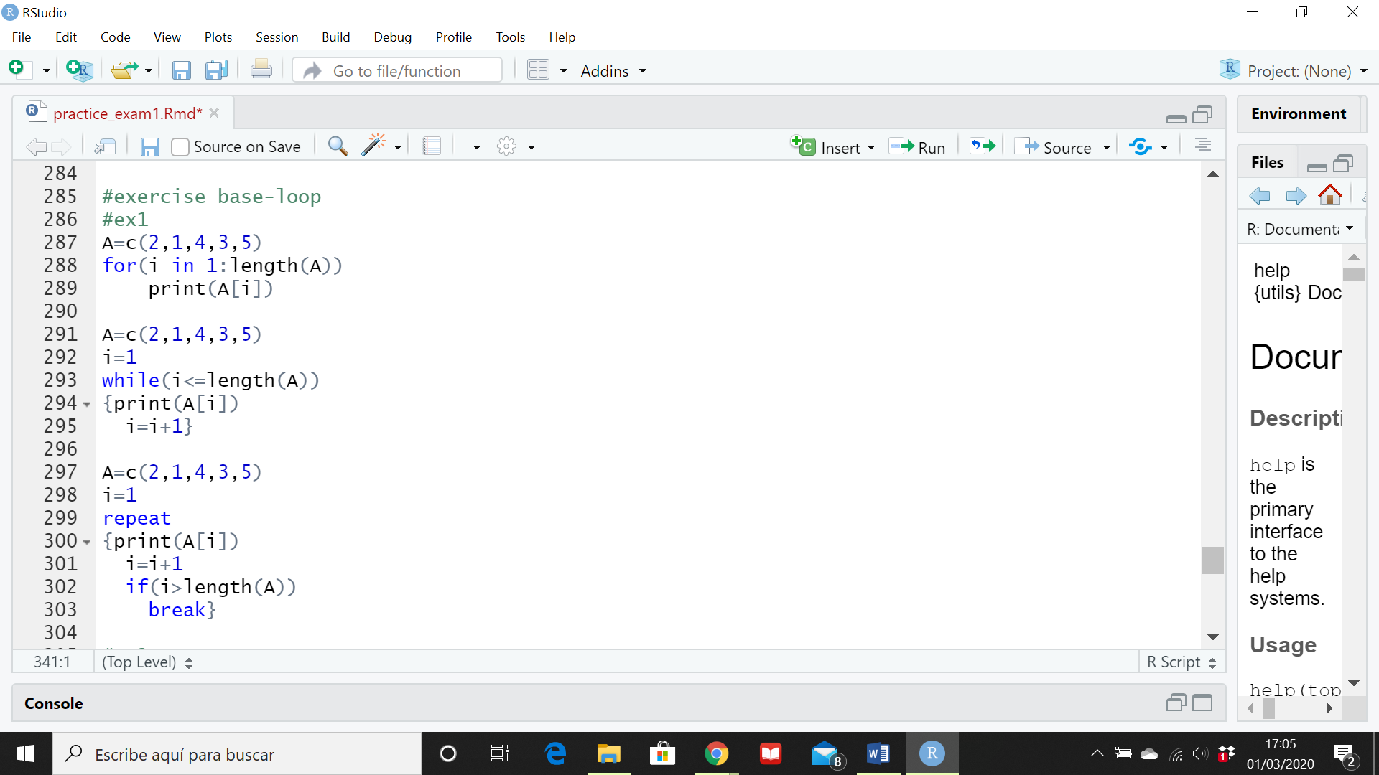

**2.- Create a function that show elements of a vector from right to left, using repeat or while loop.**

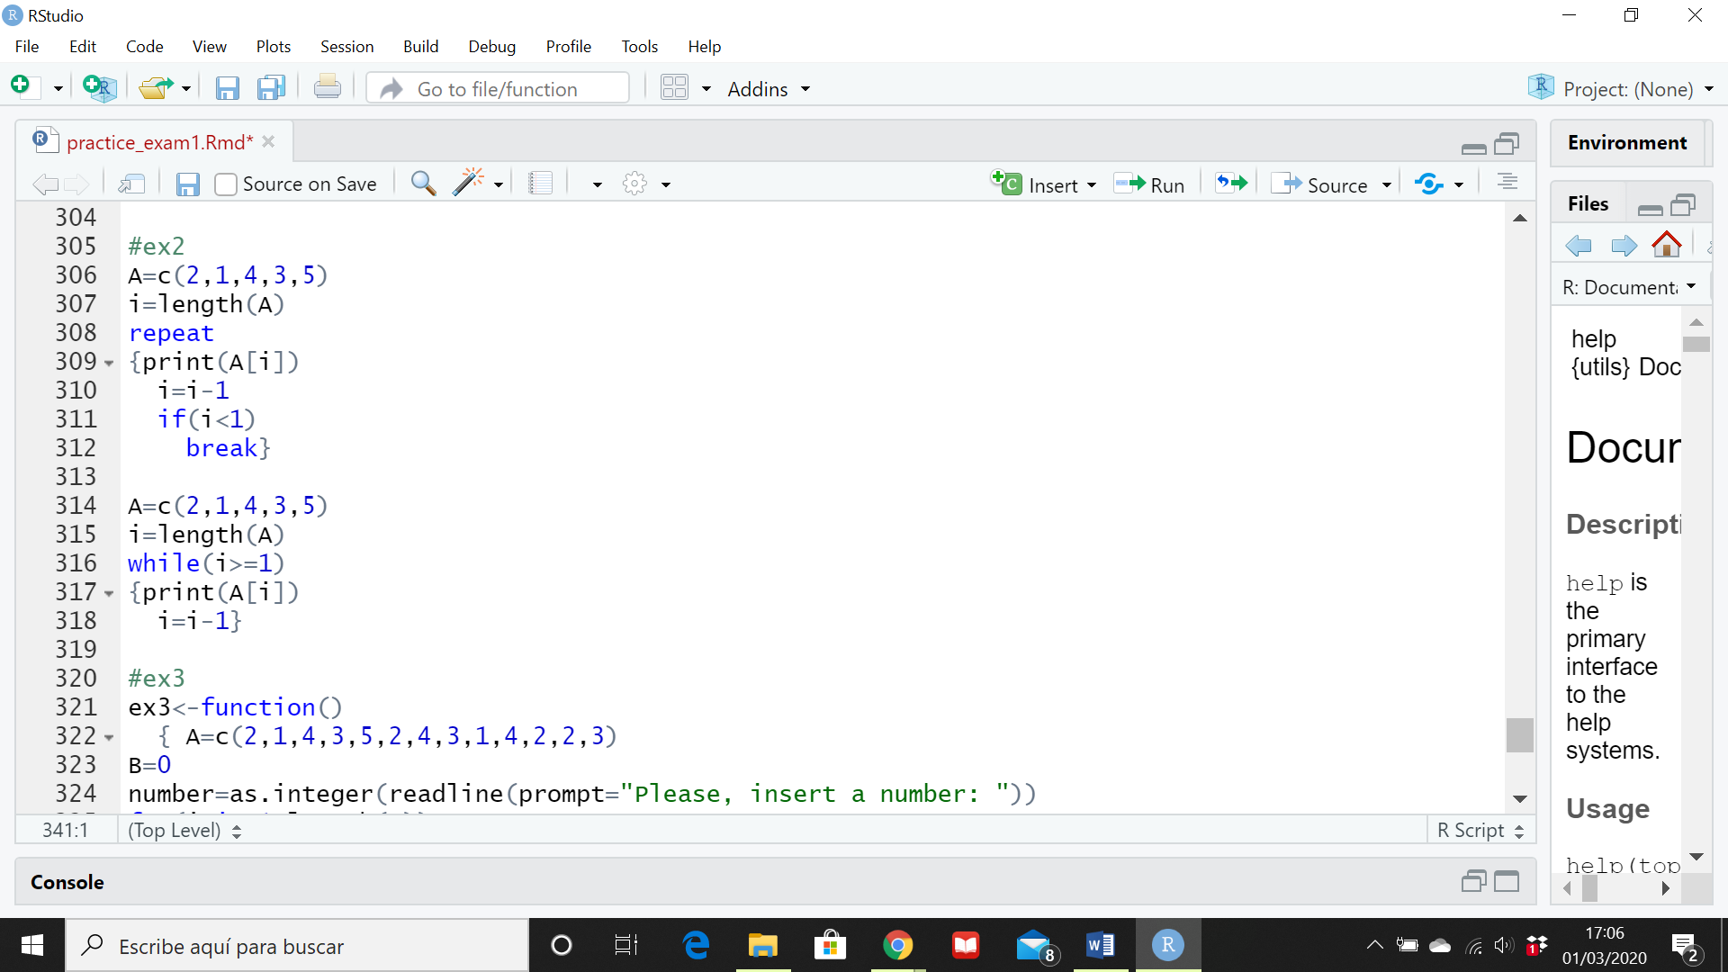

**3.- Create a function that requests a number using keyboard and counts how many times the number appears in the vector.**

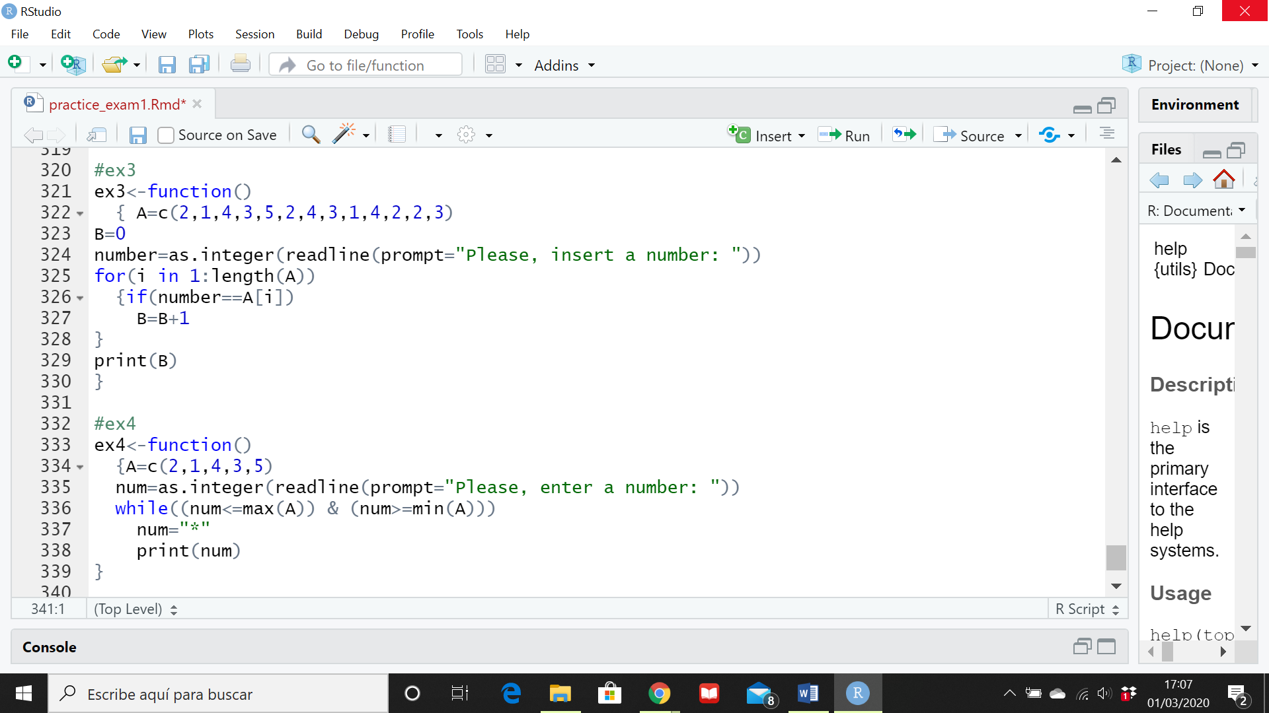

**4.- Create a function that requests a number using keyboard and modifies the number by an *.**

